***EXPERIMENT NO: 02***

***Aim:*** *To IMPLEMENT VERSION CONTROL USING GITHUB.*

***THEORY:***

*GitHub is a code hosting platform for version control and collaboration. It lets you and others work together on projects from anywhere.*

*This tutorial teaches you GitHub essentials like repositories, branches, commits, and pull requests. You'll create your own Hello World repository and learn GitHub's pull request workflow, a popular way to create and review code.*

***Why Version Control System like git is used ?***

*Real life projects generally have multiple developers working in parallel. So a version control system like Git is needed to ensure there are no code conflicts between the developers. Additionally, the requirements in such projects change often. So a version control system allows developers to revert and go back to an older version of the code. Finally, sometimes several projects which are being run in parallel involve the same codebase. In such a case, the concept of branching in Git is very important.*

***INSTALLATION:***

*Step: 1*

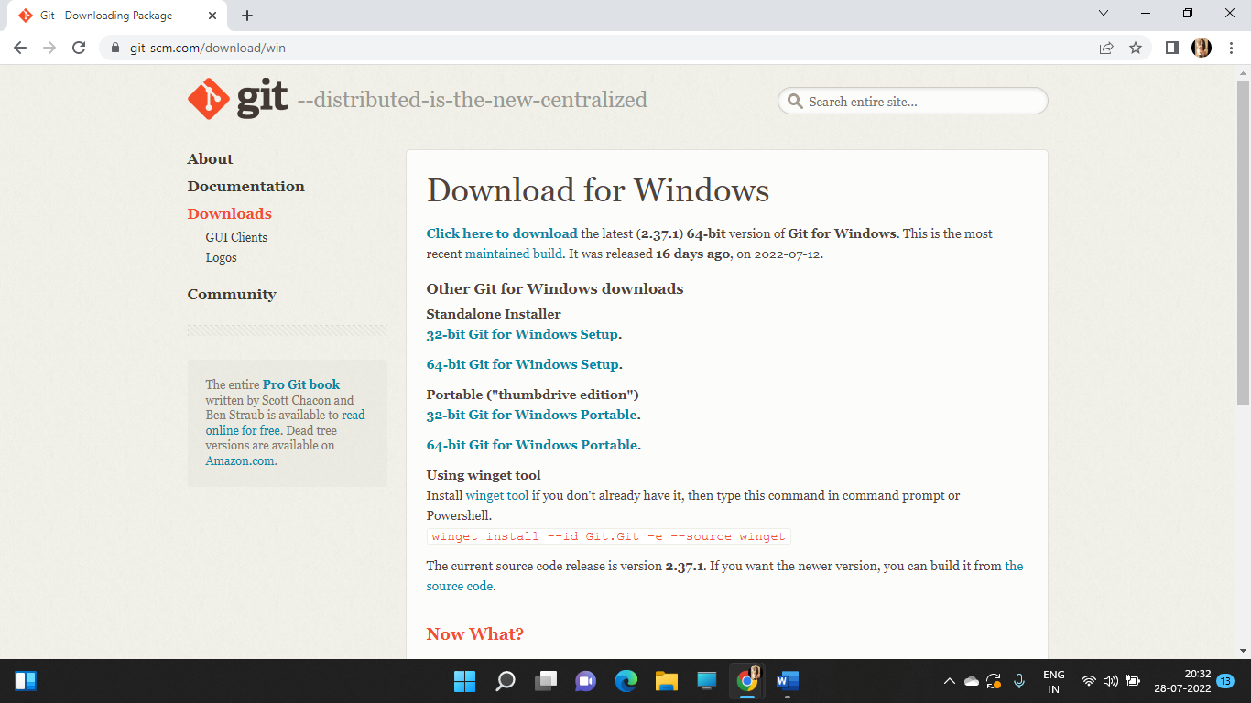

*Step: 2*

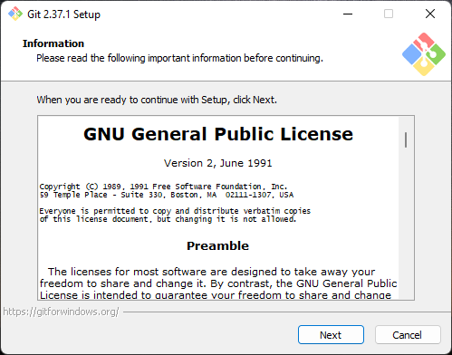

*Step: 3*

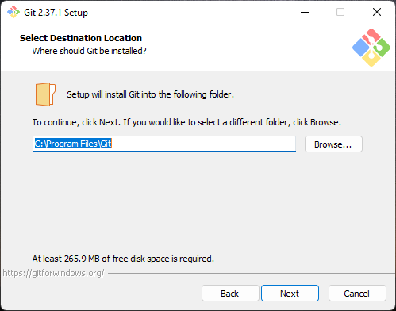

*Step: 4*

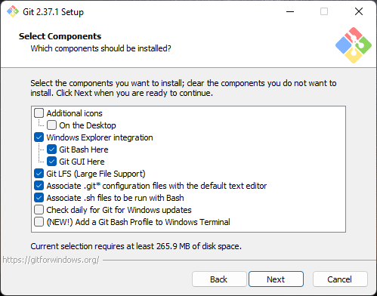

*Step: 5*

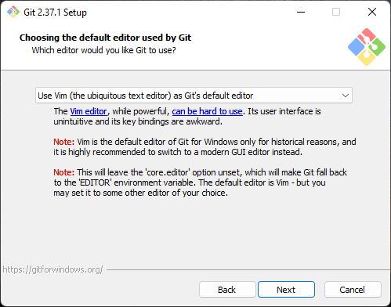

*Step: 6*

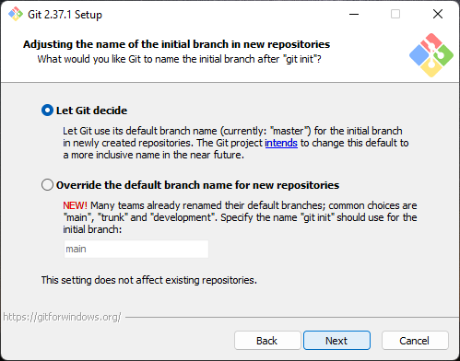

*Step: 7*

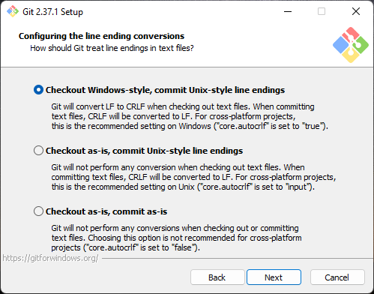

*Step: 8*

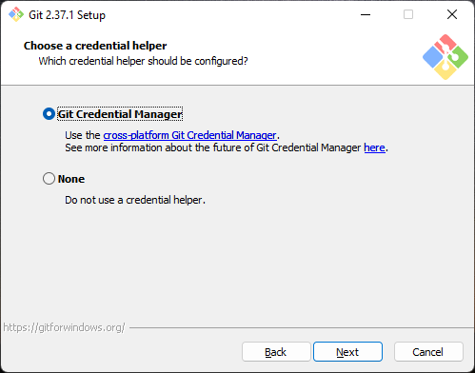

*Step: 9*

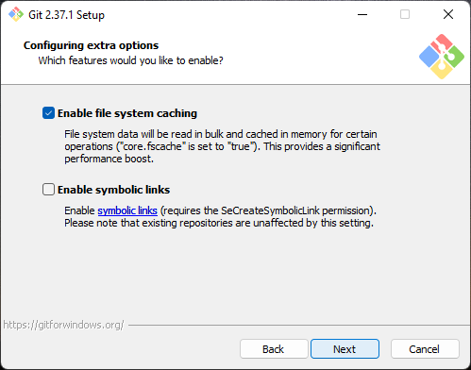

*Step: 10*

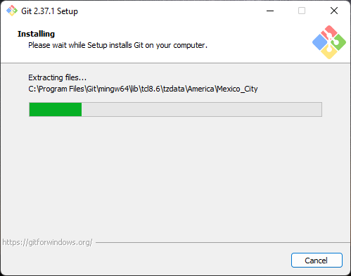

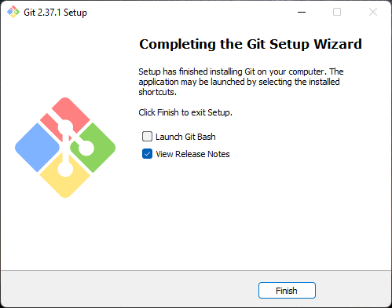

***COMMANDS:***

***2.a ls command***:

*It is used to list the content of the current working directory.*

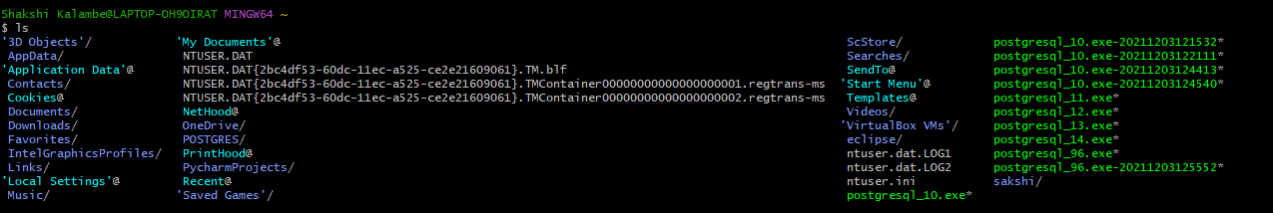

***2.b mkdir command***

*The mkdir command which stands for****make directory****allows you to create a new directory/folder.*



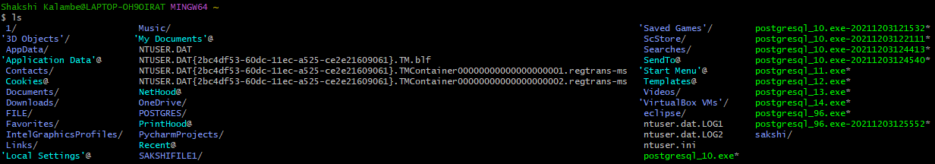

***2.c cd command***

*cd is invoked with an appended directory name. Executing cd will change the terminal sessions current working directory to the passed directory argument.*



***2.d git init command***

*The git init command creates a new Git repository. It can be used to convert an existing, unversioned project to a Git repository or initialize a new, empty repository.*



***2.e git status***

*The git status command displays the state of the working directory and the staging area. It lets you see which changes have been staged, which haven't, and which files aren't being tracked by Git.*

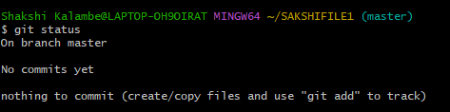

***2.f git config***

*The git config command is a convenience function that is used to set Git configuration values on a global or local project level.*

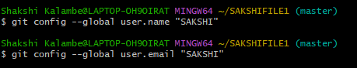



***2.g git add***

*The git add command****adds a change in the working directory to the staging area****.*



***2.h git commit***

*The git commit command captures a snapshot of the project's currently staged changes. Committed snapshots can be thought of as “safe” versions of a project Git will never change them unless you explicitly ask it to. Prior to the execution of git commit*

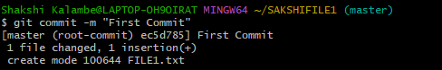

***2.i git clone***

*The git clone command is****used to create a copy of a specific repository or branch within a repository****.*

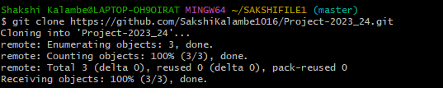

***2.j git remote add***

*To add a new remote, use the git remote add command on the terminal, in the directory your repository is stored at.*



***2.k git push origin master***

*Git Push Origin Master pushes your master branch to the origin.*

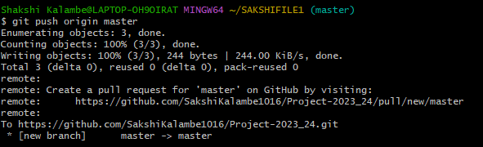

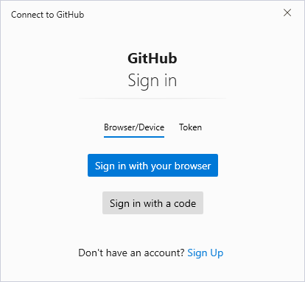

*Step: 11*

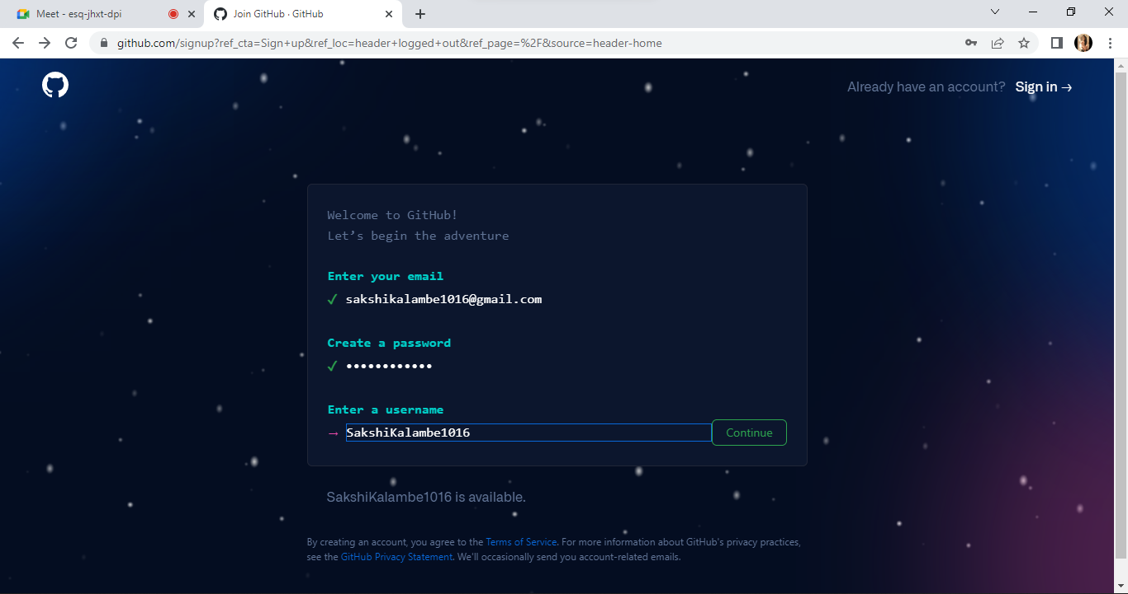

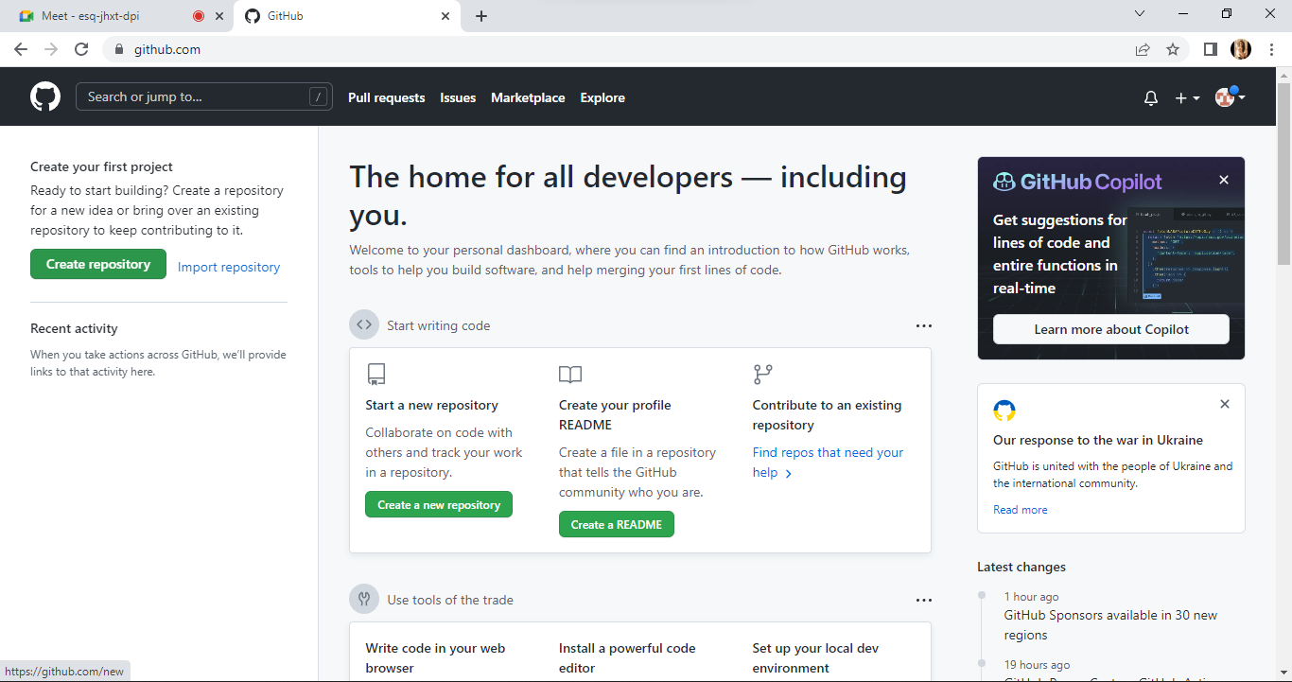

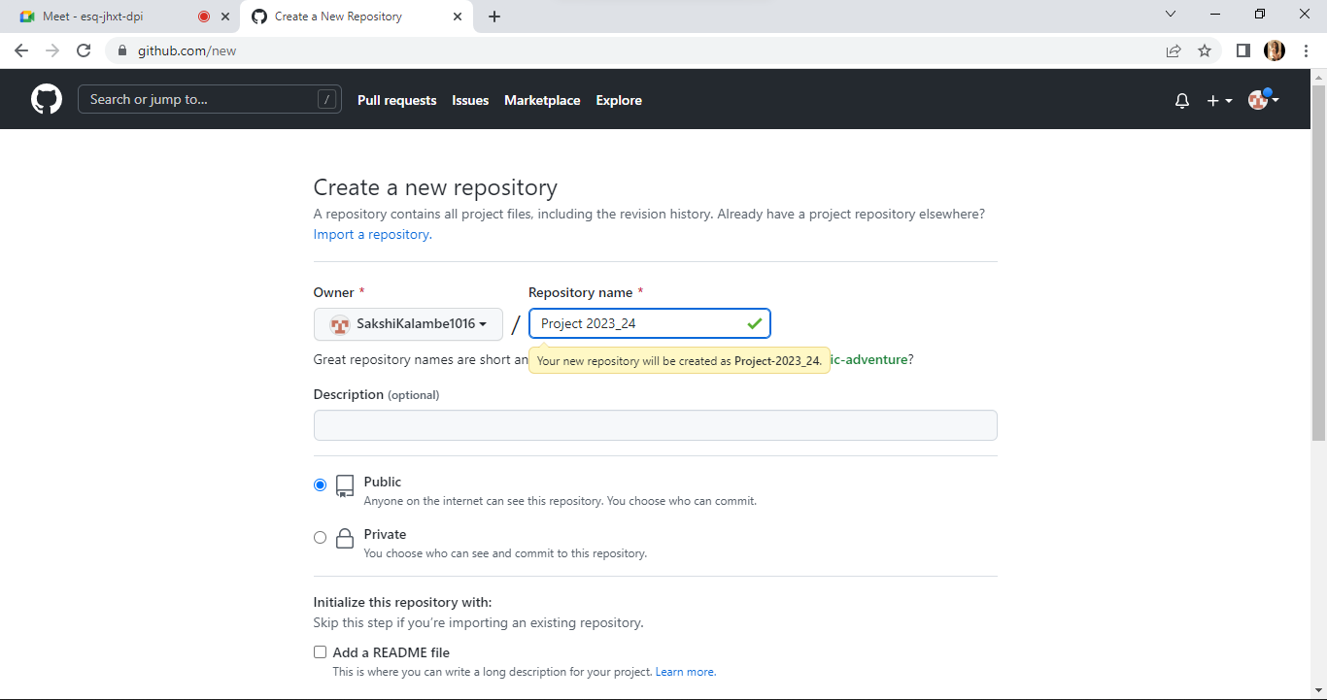

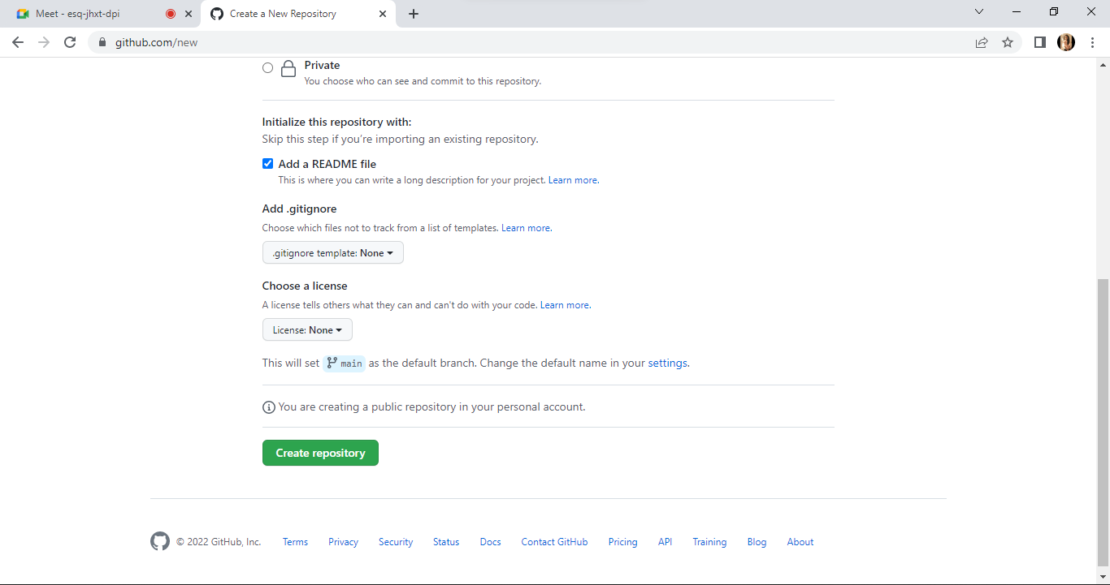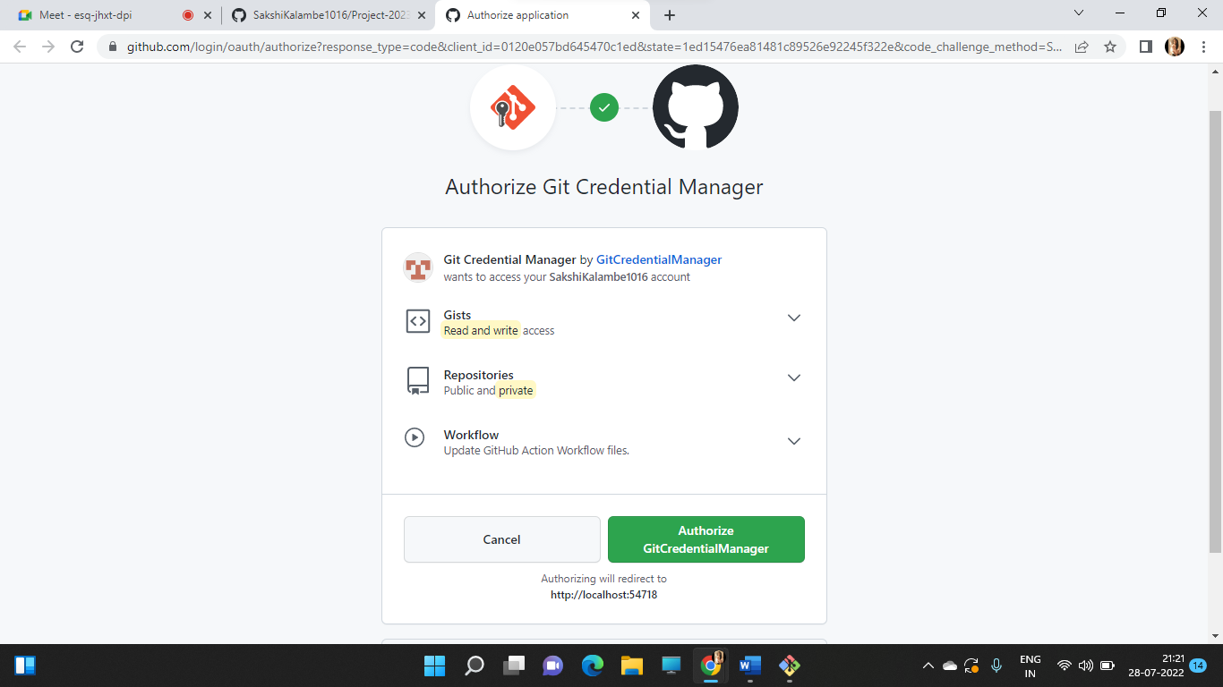

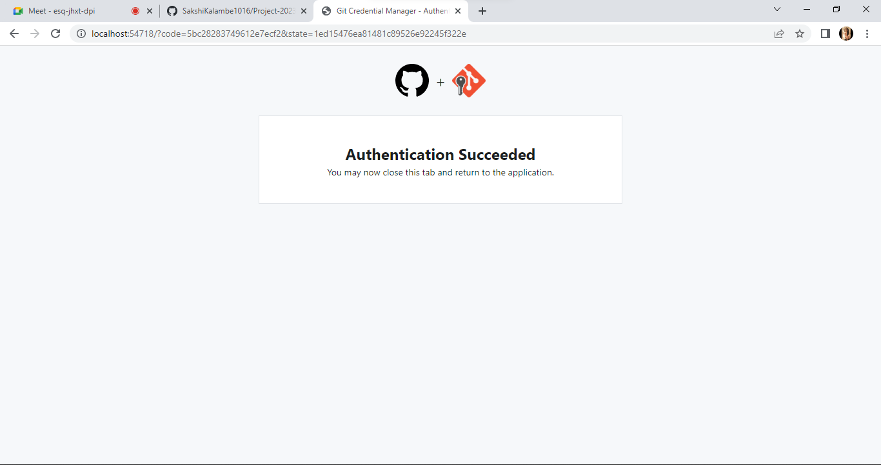

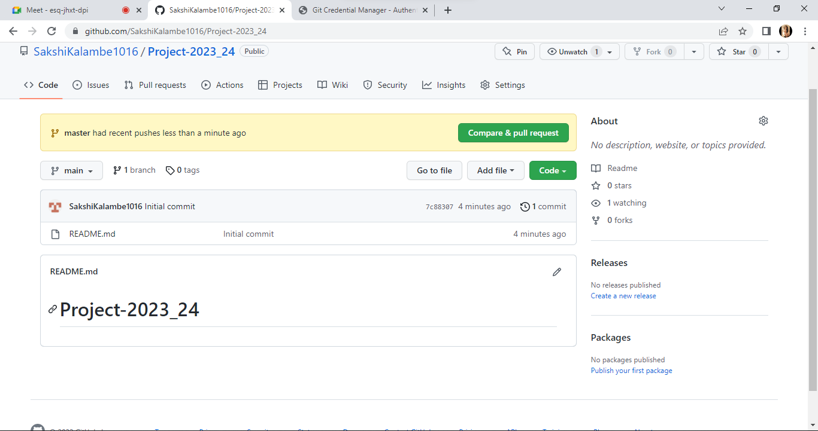

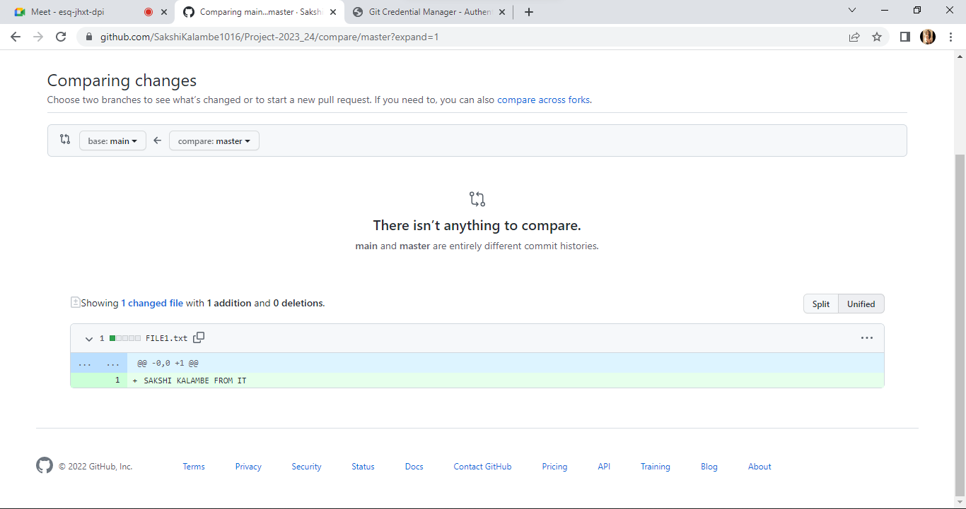

***CONCLUSION:***

*We studied different commands and installation process/steps for git And also how to create the repository.*